**Dr. Babasaheb Ambedkar Technological University, Lonere**



**A Report On**

**“Online Examination System”**

**Submitted By**

**Khadkale Tanveer M. 2022541245036**

**Palampalle Poonam L. 2022541245031**

**Hajare Janabai D. 2022541245028**

**Biradar Vishakha B. 2022541245029**

In the guidance of

Dr. Bhosale J. D.



**VILASRAO DESHMUKH FOUNDATION,**

**GROUP OF INSTITUTIONS, LATUR**

**New M.I.D.C Airport Road, Latur-413531**

DEPARTMENT OF COMPUTER ENGINEERING 2022-23

**VILASRAO DESHMUKH FOUNDATION,**

**GROUP OF INSTITUTIONS, LATUR**

**Certificate**

This is to certify that **Ms. Khadkale Tanveer Maheboob, Ms .Palampalle Poonam Lahu, Ms. Hajare Janabai Dhananjay, Ms. Biradar Vishakha Bhausaheb** of Sem VIII Class BE (CSE) has successfully completed the Project presentation on **“Online Examination System”** as prescribed by Dr. Babasaheb Ambedkar Technological University, Lonere during the year 2022-2023 in the Department of Computer Engineering.

**GUIDE HOD**

**Dr. Bhosale J. D. Asst. Prof. Wakhare Y. R.**

**Principal**

**Vilasrao Deshmukh Foundation,**

**Group of Institutions,**

**Latur**

**ABSTRACT**

Online Exam System for introduction to management is an application that is designed and developed for students and lecturers. The system helps students to take examinations online. It also helps lecturers to upload the questions and answers in the database and they can see the students who fail or pass the exam. The software is developed using Java programming language and database.

In the software we can register as a user and users are of two categories which are Lecturer and Student. Before using the system both users need to register and after that they must login with their username and password in order to enter the system. The online examination system for introduction to management is constituted of different components for instance login function, insertion of data in the database, extraction of data from the database.

The problem with the current system is that students take their exam manually. This outdated system will take long time utilization; the manual procedure used for conducting exams is a time consuming process. More time is being used for lecturers to bring the questions papers and answer sheets and also more time is needed for students in order to write their exam.

**ACKNOWLEDGEMENT**

I have taken efforts in this project. However, it would not have been possible without the kind support and help from many individuals and organizations. I would like to extend my sincere thanks to all of them.

Thanks to Dr. Bhosale J.D. of Computer department in university Dr. Babasaheb Ambedkar Technological University, Lonere, for guiding, supervising, providing me with necessary information about the project and correcting various prototypes and documents of mine with attention and care. He has gone with me through the project and without his help I was not able to complete my project.

We also would like to express my gratitude towards our Dr. Babasaheb Ambedkar Technological

University, Lonere and all our respected professors in the university who have given us a great chance to undergo this project and also provide us with knowledge to complete it.

Our thanks and appreciations also go to my colleagues in developing the project and people who have willingly helped me out with their abilities.

We would like to thank my family for their help and their encouragement which assisted me in completing my project.

**DECLARATION**

I hereby declare that the project entitled, “Online Examination System” done at Vilasrao Deshmukh Foundation,Group of Institutions, Latur has not been in any case duplicated to submit to any other university for the award of any degree. To the best of my knowledge other than me, no one has submitted to any other university.

The project is done in partial fulfilment of the requirements for the award of degree of BACHELOR IN TECHNOLOGY (COMPUTER ENGINEERING) to be submitted as a final semester project as part of our curriculum.

Khadkale Tanveer M.

Palampalle Poonam L.

Hajare Janabai D.

Biradar Vishakha B.

**CONTENT**

**ABSTRACT**

**CHAPTER 1: INTRODUCTION** 1

1.1. Background of Study 2

1.2. Problem Statement 2

1.3. Objectives and Scope of Study 3

1.4. Project relevancy, feasibility 3

**CHAPTER 2: LITERATURE REVIEW** 4

2.1. Examples of online exam system 5

2.2. Computerized Systems 6

2.3. Web-based application 7

2.4. Programming languages on the World Wide Web 8

**CHAPTER 3: METHODOLOGY** 10

3.1. Research Methodology 10

3.2. Project Activities 10

3.3. Tools 13

3.4. Software Requirement Specification 15

**CHAPTER 4: RESULT AND DISCUSSION** 24

4.1. Questionnaire survey analysis 24

4.2. use case diagram 18

4.3 system flow chart 19

4.4 entity relationship diagram 20

4.5 context diagram 21

4.6 database design 27

4.7. Interface requirements 29

4.8. Test plan 32

4.9. Test approaches 33

4.10. Test cases 36

4.11. Test tools needed 39

**CHAPITRE 5: CONCLUSION RECOMMANDATION**  54

**REFERENCES** 54

**APPENDICES 55**

**LIST OF FIGURES**

Figure 1: Waterfall Model 11

Figure 2: System Flow Chart 19

Figure 3: Use Case Diagram 18

Figure 4: E-R Diagram 20

Figure 5: Contact Diagram 21

Figure 6: Login 40

Figure 7: Registration 47

Figure 8: Student report page 48

Figure 9: Adding question 48

Figure 10: About the system version 48

Figure 11: Student page 49

Figure 12: Selection of exam 49

Figure 13: Start exam 50

Figure 14: Exam question 50

Figure 15: End of exam page 51

**LIST OF TABLES**

Table 1: Milestone 18

Table 2: Gantt chart 19

Table 3: Survey 20

Table 4: User 21

Table 5: Question and answer 28

Table 6: Result

**CHAPTER 1: INTRODUCTION**

**1.1. Background of study**

Computerized and online systems have been increasing in every aspect of education. Information Technology plays a very important role in education nowadays. Computers and the internet have made dramatic changes in the education system. Information technology enables institutions of higher learning to save time and money, and allow the delivery of education with ease, anywhere, and anytime. Paper based books are replaced by online and off-line applications. With computer software, we can be able to have access to huge databases of information. This gives fundamental change to education. Information technology makes the exchanges of information fast and easy. In the modern era, technological progress has minimized the information in the world. Advancement of technology has many advantages in education and all business industries that use it. With the use of technology advances, the transaction became more rapid, accurate and efficient. As time goes by computers have become more useful for every transaction. Online Examination System for introduction to management is an application that is designed and developed for students and lecturers. The system helps students to take examinations. It also helps lecturers to upload the questions and answers in the database and they can see the students who fail or pass the exam.

**1.2. Problem Statement**

The problem with the current system is that students take their exam manually. This outdated system will take long time utilization; the manual procedure used for conducting exams is a time consuming process. More time is being used for lecturers to bring the questions papers and answer sheets and also more time is needed for students in order to write their exam. Students are not satisfied with the current system of taking the multiple choice examination. The no accuracy with current system when students did not use a 2b pencil student are losing their mark. Using the manual procedure of conducting examinations we are not saving the environment by using more paper, we are in a world where we really need to take care of the environment.

**1.3**. **Objectives and scope of study**

This project is aimed at developing an online examination system for introduction to management for students and lecturers. The purpose of the system is to completely automate the old manual procedure of conducting exam to a computerized System. I will provide a more efficient examination system.

The system will allow students to register and take the exam. It enables also lecturers to perform many tasks. The system has several functions. The users will do the registration before using the system. The lecturers can upload questions and answers; he can view the list of all students who take the exam. He can view the list of students who have grade A, grade B, grade C, grade D and those who fail the exam. The lecturers can send emails. Once logging, the students can choose the subject and take the exam. After finishing using the software the users have a logout function that allows them to sign out. This is because the system wants to ensure no external users can exploit the system.

**1.4. Project relevancy, feasibility**

**1.4.1. Technical Feasibility**

Building this system is technically feasible. The hardware and software needed are all available, it not difficult to get them. Brief I can say the necessary resources needed for the development and maintenance of the system are available. I am going to use java programming languages and database.

**1.4.2. Operationally Feasibility**

The project I am developing is operationally feasible as there is no need for users to have good knowledge in computer before using it. The user can learn and use the system with easiness; he just needs to read the manual or tutorial from the developers.

**1.4.3. Economic Feasibility**

Besides being technically feasible, developing this system is economically feasible as well. The development of the system does not require the developers to spend a lot of money. The tools I will be using to develop the system are not expensive and the software’s are open source. All I need is time. Even the maintenance of the system will not be expensive. The system is indeed economically feasible.

**CHAPTER 2: LITERATURE REVIEW**

**2. Introduction**

Computerized systems have been increasing in education nowadays. Information Technology plays a very important role in education. Computers have made dramatic changes in the learning system. Information technology enables education institutions to save space and time, and allow the delivery of education services with easiness, anywhere, and anytime. For instance physical libraries are replaced by online libraries available to anyone; anywhere in the world students can interact with lecturers online whether live or via video. With computer software, we can be able to have access to huge databases of information. This gives fundamental change to the education system. Information technology makes the exchanges of information fast and easily.

With the growth of IT a lot of data can be found in online library. We don t need to have a physical library in order to read books. Computers are a powerful tool used in all aspects of our studies. We use multimedia technologies to convey ideas, build projects.

Information technology enables students to do distance learning, method of learning at a distance instead of learning in a classroom. Communications technologies create possibilities, both individual and institutional, for an unprecedented expansion of home-based learning, much of it part-time.

Information technology provides systems that allow students to perform many tasks in an automatic way and not manually. Students can take exam using computerized system; they don’t need paper-based exam. They save time and money when using computer system in their studies.

**2.1. Examples of Exam Systems**

**Infosolutions Goa**

They provide an online Examination System to universities. It is a web-based system developed in PhP and MySQL. The examination consists of different types of multiple choice questions. The questions are selected at random keeping the proper weightage for the various topics. The answers are evaluated and the marks obtained for each along with the answer given by the student are stored in the database. The examiner can get the results immediately in various forms - the general marklist, the detailed general mark list where the marks obtained by the student in each topic of the subject is shown as well as the answer sheet of each student. The trends graph show the graph of how many students have passed in each topic of a particular subject as well as how many students have passed in each subject . There is also the provision for a Trends graph of comparing how many students have passed topic wise in each subject at the midterm as well as final exams if there are two exams for the subject.

The software maintains the details for each student as well as provides a facility for editing the student details if required. There is Password based access for Individual Answer Sheet, General Mark Lists and Trends Graphs. Authentication is provided Via Sessions and the password is stored in encrypted form (MD5 hash) in the database.

This Online Examination System in PHP and MySQL can be modified and customized to suit the need of any Educational Institutions, Primary and Secondary Schools, Colleges, Professional and Vocational Institutes, Universities or Training Academies. This software is particularly suited to conduct competitive exams like recruitment exams and Common Extrance Tests (CET) of various states as it will save valuable time spent on assessing the answer books and the results can be obtained immediately.

**Summation Technologies**

This company builds custom online exam creation and administration applications. It’s fully automated web-based examination software. The features of the software are customizable, students can do online registration. In the software they are Automated test creation randomized questions, Centralized administrator controls , In built Question database for exam questions, Access anywhere, anytime Application, Exam Format intuitive and easy to navigate ,Administrators load the questions into the database, Examinations are generated automatically as per student selections, Exams and questions can be edited, deleted, and re-used anytime, A discussion board feature so that the students can discuss problems that challenge them, Add answers hints.

**2.2. Computerized Systems**

Technology advances so fast that computers become part of our daily live. People use computers everywhere, at work, at school and at home. The computerized systems are very efficient, process huge amount of data and keep big amount of information.

Malolos ET .al (2002) says that the automated systems are important as the time and manual efforts are minimized.

Janes (2001) elaborated that computers are devices that are greatly reliable and very powerful. He said that computers possess three advantages compared to other equipments in the office. The computers have these three benefits in the sense that they are faster, more accurate and more economical.

Reyes (2005) stated that perform work manually is time consuming. But using computers make our task more practical.

In Flores (2002) point of view, he defined automation as the replacement of machine control of human.

According to Dioso (2001), computer helps in planning, organizing and controlling in an intelligent manner.

In Ralph M. Stair (1999) point of view, the growing of technology helps people to perform a lot of tasks with less effort.

Gurewich (1999) said that in any corporation the work is done faster when using database system. With the use of computerized system everything is done faster compared to tasks that are performed in a manual way.

Mane (2000) said that the invention of the computer made the task easier to perform than by doing it manually. The computer is very necessary for everyone and it is very god productivity machine. The data are stored in the computer and users can access the information whenever they are in need.

Bryan (2006) defined the information as a set of people, procedures and resources that collects processes and distributes information in an organization. They consist of simple manual information system and as well as computer based information system that uses hardware, software telecommunication and other forms of information technology.

Sender (2002) referred computers as an intelligence amplifier that can free human to use their time effectively. Computers perform tasks with high speed and accuracy. Thowsand (2005) defined database system as a structured set of data. These data can be about people, products or event.

Adamski (2007) highlighted the benefits of database by saying it is economical, a lot of information can be retrieved from some amount of data, and there is control of redundancy, integrity, security, flexibility, responsiveness, improvement of maintenance and data independence.

**2.3. Web-based application**

Web application is defined as any application that is accessed through web over a network for instance Internet or intranet. Web applications

Nijaz (2000) stated that web applications are famous from the fact that there is ability to update and maintain theses application without disturbing and installing software on millions of clients’ computers. In the same way, Bohle (2002) also elaborated the popularity of web applications because of the ubiquity of the client.

Athanassopoulos et al (2001) stated that web has revolutionized the computer and communication in an unprecedented way. According to Nijaz (2000) and Jurca (1999)

the web is world- wide and has capacity to broadcast, it s a mechanism to distribute information, a platform that allows users to collaborate, to interact regardless the geographic location.

The principal reason for enhancing the Web services is to build systems that interactive, friendly and flexible to users.

**2.4. Programming languages on the World Wide Web**

Enright (1999) enumerated that the web is the largest information store with around 36,739,000 hosts, 4,270,000 sites, and billions of documents.

The web presents graphical and texture information. With the web programming languages such as Hyper Text Markup Language (HTML), Practical Extraction and Report Language (PERL), Java, JavaScript, and Virtual Reality Modeling Language (VRML), we can create an interface that is interactive, visually and vocally interesting.

The most famous and used programming language is Hyper Text Markup Language (HTML). Apart from specifying hyperlinks, it describes the syntax and location of specific directions that indicates how text, images, graphics, and video within a Web page are displayed on a browser. Since its creation HTML has been developed in different versions. The World Wide Web Consortium located at Massachusetts Institute of Technology is the body that is in charge of developing the standards for HTML. The first version of HTML (HTML 1.0) was developed in order to publish scientific articles on the web. The second version which is HTML 2.0 was designed in 1994 and additional features such as text field, pop-menus and buttons. The next year the third edition HTML 3.0 was. Nowadays many people use HTML 4.0 and HTML 5.0 which is the latest version. HTML is created with standard text editors. Many software are used to develop and edit HTML for example: Symantec Visual Page, Macromedia Dreamweaver, and Microsoft Front Page.

Internet has a very useful aspect that is the capability to interact with servers. This is achieved by using the Common Gateway Interface (CGI) scripts. They are scripts that are used to accomplish a predefined task when initiated by the user. The scripts perform task such as searching and executing on the server when a client makes a click on elements on the webpage (Newton, 1998). Practical Extraction and Report Language

(PERL) is one of the most common and famous methods that allows to write CGI scripts. PERL was created in 1986. Biedby (1997) stated that PERL is powerful and flexible like high-level programming such as C and it is easy to learn. Element of animated Web pages and user interactivity are supported by the web. There are many programming language that can be used to develop theses web elements for instance Sun Microsystems’ Java. Harold (1997) said that Java is an object-oriented language with element from C, C++ and other languages, and with libraries for the Internet environment. Harold (1997) stated that Java is the first programming language developed with networking in mind. It provides qualities that are important for instance platform-independence and security. It enables to create applications and left on the web and users can download anytime they are in need. Besides Java programming we have also JavaScript that allows developing a system that is interactive, real time responsive. Newton (1998) said that JavaScript is an alternative of Java designed to enhance web pages and servers. With JavaScript Standalone application are embedded into HTHL or Java applets. Ritchey (1996) stated that JavaScript has the capability that allows developing systems that are responsive to user with no need of server-side program. JavaScript is interpreted by the browser when it is executed. The Web is also used for 3-D graphics presentation. This feature is accomplished with the use of modelling language called Virtual Reality Modeling Language (VRML). This language was created in 1995 and allows creating dynamic worlds and sensory-rich virtual environments on the Internet. Using VRML, we can create buildings; vehicles in a 3-D dimensional virtual world can be seen on the web. Ames (1997) elaborated that VRML enables object animation, audio, video and user interaction to be incorporated through the use of script.

**CHAPTER 3: METHODOLOGY**

**3.1 Research Methodology**

Main methodology activities held during the research is acquiring information and knowledge about online examination system through reading books, and researches that were previously done in related area. All the research materials were obtained over the internet, Wikipedia and other websites.

Next step taken is reading, comprehending and analyzing literature review and matching information obtained. This research emphasize online examination system, which include usability, user-friendly interface, reliability, costing and meeting needs of target users.

**3.2 Project Activities**

In order to give solution to problems in an industry, software developer or a team of developers must incorporate a development strategy that encompasses the process, methods and tools layers and generic phases. This strategy is often referred to as process model or a software developing paradigm. A process model for software developing is chosen based on the nature of project and application, the methods and tools to be used, and the controls and deliverables that are required. All software development can be characterized as a problem solving loop in which distinct stages are encountered. Regardless of the process model that is chosen for a software project, all of the stages coexist simultaneously at some level of detail.

The methodology chosen to develop this system is waterfall model approach. I opted for this method because I found that it is the best for my project where the stages involved can assist my level of progress. Many developers prefer waterfall model and widely use it as a development strategy.

Waterfall model approach is chosen because the approach allows the development of the system to be revised after the stages is finished. Once the stages are not satisfied, then going back to the previous stages can be considered necessary to add or modify any features. The different stages for this model:

Project Planning

* Requirements Design
* Design
* Development
* Integration and Testing
* Installation and Acceptance

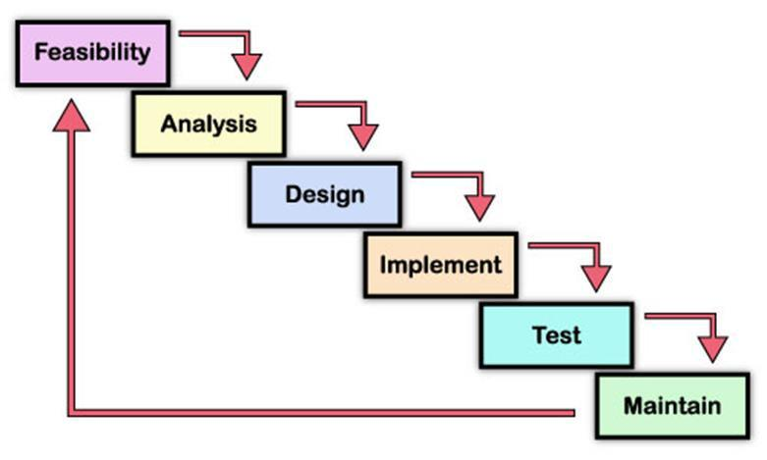

Figure 1: Waterfall Model

**3.2.1. Planning**

The purpose of this phase is to determine the best solution and steps taken to develop the system. Planning involves the details planning for the timing of the working progress and types of technique will be taken next. Planning also involves that the methodology that will going to use for this project.

**3.2.2. Requirement Analysis**

The purpose of this phase is to build logical model of this system. In addition, this phase also needed to understand the applications, fact finding technique like document reviews, surveys, observations, and sampling must be made to identify application requirement, software requirement and hardware requirement. In this phase, what kind of data requirement and the functional requirement will been decide.

**3.2.3. Design**

This phase will produce draft of the system architecture and the prototype of the application that will satisfy all requirement analysis. At this phase the user interface and all necessary input and process will be identify. This phase also determine the application architecture, which is going to shows how to transform the logical design into basic system coding to generate the first prototype of the system. The result for this phase application interface and system design specification. For this project, the design will be created using the Java Net beans.

**3.2.4. Implementation**

During this implementation phase, the system will be constructed. All codes are generated inside this phase. At the end of this phase, system should running and most of the function for the system should be able to use. Based from the previous phase, from the prototype, the system will become the first version inside this phase.

**3.2.5. Testing**

This phase will evaluate or verify the system that was developed. This phase will have a simulation data which will simulate the true database for the system. This is to test the functionality of the system in comparing a capture data with a database. Beside, all the functionality that may cause errors or problems to the system must be specified inside this phase because, the final result of the system is a very high priority and important. However, the testing phase will only cover to overcome the problem statement and the system objectives.

**3.3 Tools**

The tools required to develop the system are: Net Beans IDE 67.2, Microsoft Access 2007, MySQL in XAMPP, Microsoft Words 2007 and Gantt chart software.

**3.3.1** Net Beans IDE 7.2

The Net Beans IDE is a free and open source software development tool that allow developers to create enterprise, web, desktop, and mobile applications. The Net Beans IDE 7.2 is an Integrated Development Environment available for Windows, Mac, Linux, and Solaris. The Net Beans project consists of an open-source IDE and an application platform which enable me to rapidly create the software using Java programming language.

**3.3.2** Microsoft Project

Microsoft Project is a project management software program, developed by Microsoft, which is designed to assist a project manager in developing a plan, assigning resources to tasks, tracking progress, managing the budget and analyzing workloads.

The application creates critical path schedules, and critical chain and event chain methodology third-party add-ons also are available. Schedules can be resource leveled, and chains are visualized in a Gantt chart. Additionally, MS Project can recognize different classes of users. These different classes of users can have differing access levels to projects, views, and other data. Custom objects such as calendars, views, tables, filters, and fields are stored in an enterprise global which is shared by all users.

I use it to plan and manage the time more efficiently.

**3.3.3** MySQL

MySQL is an open source RDBMS that relies on SQL for processing the data in the database. MySQL provides APIs for the languages C, C++, Eiffel, Java, Perl, PHP and Python. In addition, OLE DB and ODBC providers exist for MySQL data connection in the Microsoft environment. A MySQL .NET Native Provider is also available, which allows native MySQL to .NET access without the need for OLE DB.

MySQL is most commonly used for Web applications and for embedded applications and has become a popular alternative to proprietary database systems because of its speed and reliability. MySQL can run on UNIX, Windows and Mac OS. MySQL is developed, supported and marketed by MySQL AB. The database is available for free under the terms of the GNU General Public License (GPL) or for a fee to those who do not wish to be bound by the terms of the GPL

**3.3.4** Microsoft word Office

Microsoft Words is Microsoft’s word processing software that I chose to document all the documentation part. With Microsoft Word 2007, I found out that there are many benefit of using it e.g. Live Preview which enables us to view the document without making any permanent changes, Mini Toolbar, Super-tooltips, Quick Access toolbar, SmartArt, and many more.

**3.3.5** Microsoft PowerPoint

This application is used for the documentation and presentation of the project. Microsoft PowerPoint, usually just called PowerPoint, is a commercial presentation program developed by Microsoft. It is part of the Microsoft Office suite, and runs on Microsoft Windows and Apple's Mac OS X operating system.

**3.3.6** Operating System

For the project I use Windows 7 64-bits which is the latest release of Microsoft Windows, a series of operating systems produced by Microsoft for use on personal computers, including home and business desktops, laptops; notebooks, tablet PCs, and media center PCs.

**3.3.7** Hardware

The hardware that I have used to develop the system is a laptop Asus vivo book with Intel core i3 quad-core processor. The RAM is 4GB.

**3.4 Software Requirement Specification**

**3.4.1**. Functional requirement

**3.4.1.1.** Software product features

**3.4.1.2** Login/Logout

To assure the security of the system, the user should sign before starting using the system and sign out after he finishes.

**3.4.1.3** Register

Users should create an account and their data are registered in the database.

**3.4.1.3.1** Send Email

Lecturers can send email to students to give some announcements regarding the exam.

**3.4.1.3.2** Upload

Lecturers can add questions and answers to the system

**3.4.1.3.3** View/ Student Report

This allows lecturers to view the students who fail or pass the exam. They can view according to grade A, B, C, D or F.

**3.4.1.3.4** Help

This enables users to see the information about the system and also the user manual.

**3.4.1.3.5** Select

This feature helps students to choose the subject and then proceed to answer the questions.

**3.4.2** Non-functional requirement

**3.4.2.2** Reliability

The system can update its content in real time. Therefore, changes such as addition, deletion or modification can be done immediately. This ensures that the content of the system is up-to-date, reliable and can be trusted. The system will also be able to produce all related output to queries.

**3.4.2.3** Availability

The system can operate 24 hours per week and 365 days a year. As long as the user not shut down the desktop. All the information will be keep in the database. Even though, the desktop is shut off information still exist in the database.

**3.4.2.4** Security and Safety

In order to avoid security and safety breach occur users need to login with username and password before they access the system. In database there have record the username and password. Only registered users can access the system and use it.

**3.4.2.5** Maintainability

The software is being developed by the Java NetBeans IDE 6.8. Thus the system can be update in the coding part to maintain the system.

**3.4.2.6** Portability

The system is being developed using Java programming language and MySQL. Before the system release to system needs to compile without any error before the system run. Therefore, the software will be able to run on any computer with NetBeans IDE 6.8 and MySQL.

**3.4.2.7** Performance

The system performance is very fast. The processed transactions and event response time is quick. So user can do the transaction any event without feel stress on waiting.

**3.4.2.8** Flexibility

System is working easily on the Intranet with the username and password of the user. The system has given the rights to the lecturers and the students to use the system with their username. The system can also work on other kind of technology with the little modification. System should be quite flexible to install and maintain.

**3.4.2.9** Efficiency

System should be efficient enough to meet all kinds of requirements as required by the lecturers and students. The system should not hang or lose its efficiency in any kind of worse conditions. It should provide the correct output in all manners.

**3.4.2.10** User Friendliness

System should be user friendly, so that any user can use and access the system with easiness.

**4.2. Use case diagram**

The unified modeling language used is use case diagram. A use case is a set of scenarios that describes an interaction between a user and a system. A use case diagram displays the relationship among actors and use cases. The two main components of a use case diagram are use cases and actors. The actors in our system are students and lecturers. The use case diagram is designed in the following figure.

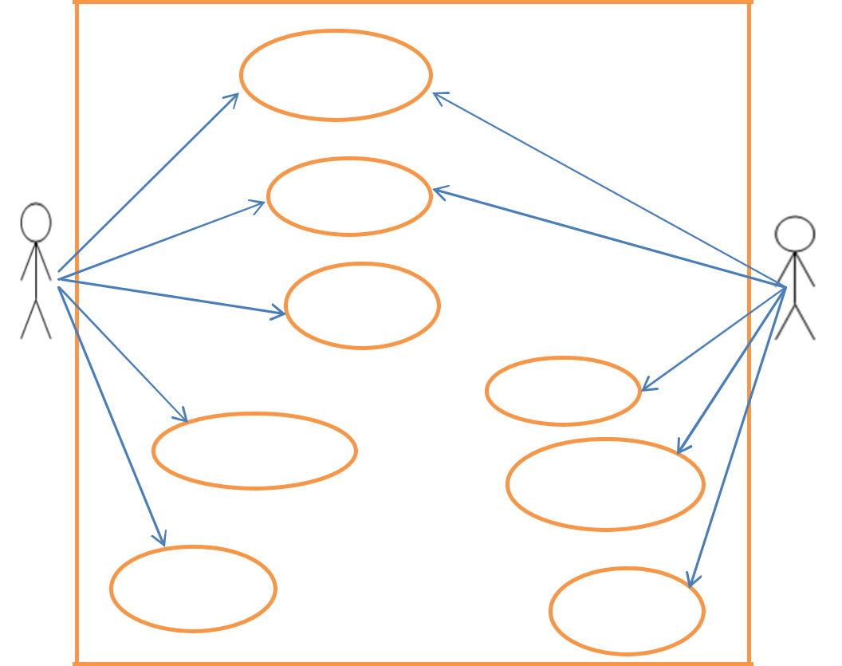

Registration

Login

Logout

Student

lecturer

Choose Exam

View student

Upload

report

**4.3. System flow chart**

A system flowchart is a valuable presentation aid because it shows how my system major components fit together and interact. In effect, it serves as a system roadmap.

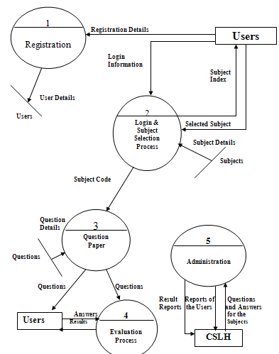

**4.4.** **Entity Relationship Diagram**

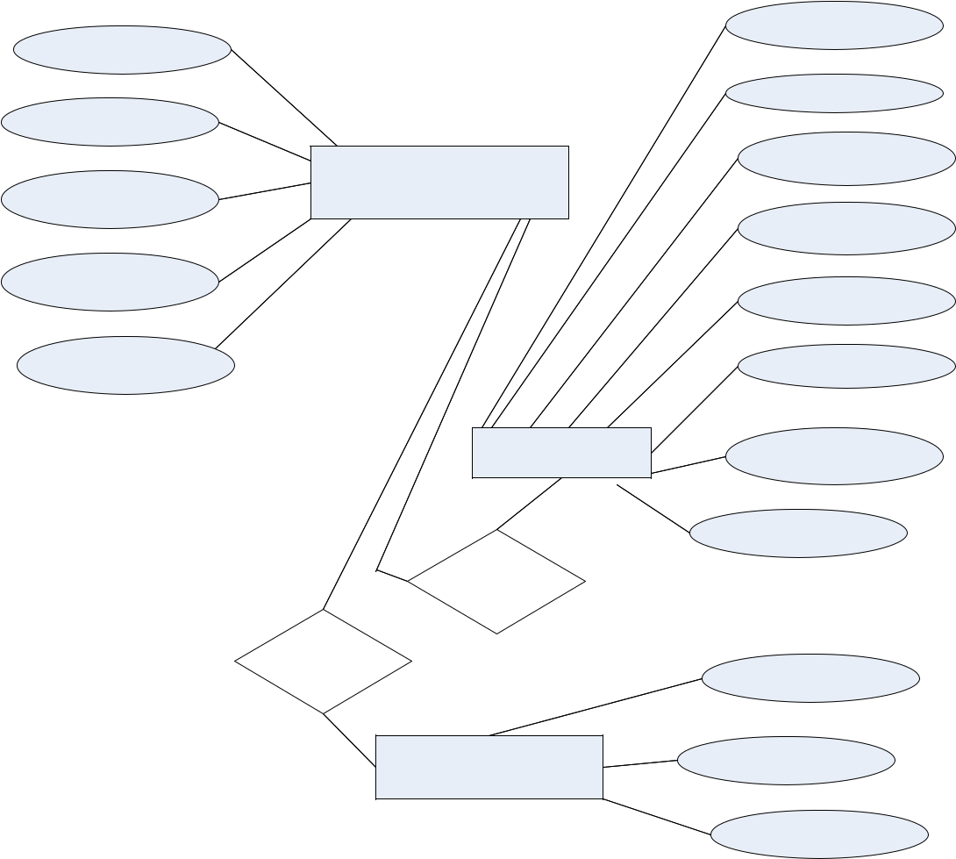

ID/STAFF

Password

Confirm password

Category

Mobile number

users

QuestionsAnswers

solve

See

Result

Subject

QuestionNum

questions

Choice1

Choice2

Choice3

Choice4

CorrectAnswer

ID

Grade

Percentage

**4.5. Context Diagram**

The Context Diagram shows the system under consideration as a single high-level process and then shows the relationship that the system has with other external entities.

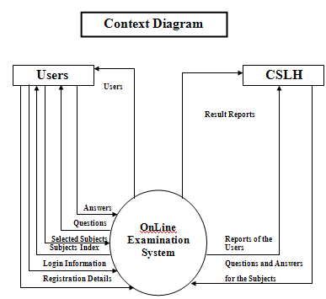

|  |  |  |  |  |  |  |  |  |  |  |  |  |  |  |  |  |  |  |  |  |  |  |  |  |  |  |  |  |  |  |  |  |  |  |  |  |  |  |  |  |  |  |  |  |  |  |  |  |  |  |  |
| --- | --- | --- | --- | --- | --- | --- | --- | --- | --- | --- | --- | --- | --- | --- | --- | --- | --- | --- | --- | --- | --- | --- | --- | --- | --- | --- | --- | --- | --- | --- | --- | --- | --- | --- | --- | --- | --- | --- | --- | --- | --- | --- | --- | --- | --- | --- | --- | --- | --- | --- | --- |
| **KEY MILESTONE** | | | | | | |  |  |  |  |  |  |  |  |  |  |  |  |  |  |  |  |  |  |  |  |  |  |  |  |  |  |  |  |  |  |  |  |  |  |  |  |  |  |  |  |  |  |  |  |  |
| Table 1. | | Key milestones for Semester 1 | | | | | | | | | | | | |  |  |  |  |  |  |  |  |  |  |  |  |  |  |  |  |  |  |  |  |  |  |  |  |  |  |  |  |  |  |  |  |  |  |  |  |  |
|  |  |  |  |  |  |  |  |  |  |  |  |  |  |  |  |  |  |  | |  |  |  | |  |  |  |  |  |  |  |  |  |  |  |  |  |  |  |  |  |  |  |  |  |  |  |  |  |  |  |  |
|  |  |  |  |  |  |  |  |  |  |  | Timelines for FYP1 | | | | | | | | | | | | | | | | | | | |  |  |  |  |  |  |  |  |  |  |  |  |  |  |  |  |  |  |  |  |  |
|  |  |  |  |  |  |  |  |  |  |  |  |  |  |  |  |  |  |  |  |  |  |  |  |  |  |  |  |  |  |  |  |  |  |  |  |  |  |  |  |  |  |  |  |  |  |  |  |  |  |  |  |
| No | Details | |  |  |  |  |  |  |  |  |  |  |  |  |  |  |  |  |  |  |  |  |  |  |  |  |  |  |  |  |  |  |  | Weeks | | | | | |  |  |  |  |  |  |  |  |  |  |  |  |
|  |  |  |  |  |  |  |  |  |  |  |  |  |  |  |  |  |  |  |  |  |  |  |  |  |  |  |  |  |  |  |  |  |  |  |  |  |  |  |  |  |  |  |  |  |  |  |  |  |
|  |  |  |  |  |  |  | 1 | |  | 2 | |  | 3 | |  | 4 | | |  | 5 | | |  | 6 | | |  | 7 | | |  | 8 | |  | 9 | | 10 | |  | 11 | |  | 12 |  | 13 | | 14 | |  | 15 | |
|  |  | | |  |  |  |  |  |  |  |  |  |  |  |  |  |  |  |  |  |  |  |  |  |  |  |  |  |  |  |  |  |  |  |  |  |  |  |  |  |  |  |  |  |  |  |  |  |  |  |  |
| 1 | Title selection proposal | | | | | |  |  |  |  |  |  |  |  |  |  |  |  |  |  |  |  |  |  |  |  |  |  |  |  |  |  |  |  |  |  |  |  |  |  |  |  |  |  |  |  |  |  |  |  |  |
|  |  | | |  |  |  |  |  |  |  |  |  |  |  |  |  |  |  |  |  |  |  |  |  |  |  |  |  |  |  |  |  |  |  |  |  |  |  |  |  |  |  |  |  |  |  |  |  |  |  |  |
| 2 | Submit proposal | | | | | |  |  |  |  |  |  |  |  |  |  |  |  |  |  |  |  |  |  |  |  |  |  |  |  |  |  |  |  |  |  |  |  |  |  |  |  |  |  |  |  |  |  |  |  |  |
|  |  | | |  |  |  |  |  |  |  |  |  |  |  |  |  |  |  |  |  |  |  |  |  |  |  |  |  |  |  |  |  |  |  |  |  |  |  |  |  |  |  |  |  |  |  |  |  |  |  |  |
| 3 | Extended Proposal | | | | | |  |  |  |  |  |  |  |  |  |  |  |  |  |  |  |  |  |  |  |  |  |  |  |  |  |  |  |  |  |  |  |  |  |  |  |  |  |  |  |  |  |  |  |  |  |
|  |  | | |  |  |  |  |  |  |  |  |  |  |  |  |  |  |  |  |  |  |  |  |  |  |  |  |  |  |  |  |  |  |  |  |  |  |  |  |  |  |  |  |  |  |  |  |  |  |  |  |
| 4 | Proposal defense | | | | | |  |  |  |  |  |  |  |  |  |  |  |  |  |  |  |  |  |  |  |  |  |  |  |  |  |  |  |  |  |  |  |  |  |  |  |  |  |  |  |  |  |  |  |  |  |
|  |  | | |  |  |  |  |  |  |  |  |  |  |  |  |  |  |  |  |  |  |  |  |  |  |  |  |  |  |  |  |  |  |  |  |  |  |  |  |  |  |  |  |  |  |  |  |  |  |  |  |
| 5 | Project works continue | | | | | |  |  |  |  |  |  |  |  |  |  |  |  |  |  |  |  |  |  |  |  |  |  |  |  |  |  |  |  |  |  |  |  |  |  |  |  |  |  |  |  |  |  |  |  |  |
|  |  | | |  |  |  |  |  |  |  |  |  |  |  |  |  |  |  |  |  |  |  |  |  |  |  |  |  |  |  |  |  |  |  |  |  |  |  |  |  |  |  |  |  |  |  |  |  |  |  |  |
| 6 | Interim Report | | | | | |  |  |  |  |  |  |  |  |  |  |  |  |  |  |  |  |  |  |  |  |  |  |  |  |  |  |  |  |  |  |  |  |  |  |  |  |  |  |  |  |  |  |  |  |  |
|  |  |  | |  |  |  |  |  |  |  |  |  |  |  |  |  |  |  |  |  |  |  |  |  |  |  |  |  |  |  |  |  |  |  |  |  |  |  |  |  |  |  |  |  |  |  |  |  |  |  |  |
| Table 2. | | Key milestones for Semester 2 | | | | | | | | | | | | |  |  |  |  |  |  |  |  |  |  |  |  |  |  |  |  |  |  |  |  |  |  |  |  |  |  |  |  |  |  |  |  |  |  |  |  |  |
|  |  |  |  |  |  |  |  |  |  |  |  |  | |  |  | |  |  | | |  |  | | |  |  |  | |  |  |  |  |  |  |  |  |  |  |  |  |  |  |  |  |  |  |  |  |  |  |  |
|  |  |  |  |  |  |  |  |  | **Timelines for FYP2** | | | | | | | | | | | | | | | | | | | | | |  |  |  |  |  |  |  |  |  |  |  |  |  |  |  |  |  |  |  |  |  |
|  |  |  |  |  |  |  |  |  |  |  |  |  |  |  |  |  |  |  |  |  |  |  |  |  |  |  |  |  |  |  |  |  |  |  | |  |  |  |  |  |  |  |  |  |  |  |  |  |  |  |  |
|  | Details | |  |  |  |  |  |  |  |  |  |  |  |  |  |  |  |  |  |  |  |  |  |  |  |  |  |  |  |  | Weeks | | | | | |  |  |  |  |  |  |  |  |  |  |  |  |  |  |  |
| No |  |  |  |  |  |  |  |  |  |  |  |  |  |  |  |  |  |  |  |  |  |  |  |  |  |  |  |  |  |  |  |  |  |  |  |  |  |  |  |  |  |  |  |  |  |  |  |  |  |
|  | 1 |  |  | 2 |  | 3 | |  | 4 | |  | 5 | |  |  | 6 | |  |  | 7 | |  |  | 8 | |  |  | 9 |  |  | 10 | |  | 11 |  |  | 12 |  | 13 | |  |  | 14 |  | 15 | |  |  |
|  |  |  |  |  |  |  |  |  |  |  |  |  |  |  |  |  |  |  |  |  |  |  |  |  |  |  |  |
|  |  | |  |  |  |  |  |  |  |  |  |  |  |  |  |  |  |  |  |  |  |  |  |  |  |  |  |  |  |  |  |  |  |  |  |  |  |  |  |  |  |  |  |  |  |  |  |  |  |  |  |
| 1 | Project | | works |  |  |  |  |  |  |  |  |  |  |  |  |  |  |  |  |  |  |  |  |  |  |  |  |  |  |  |  |  |  |  |  |  |  |  |  |  |  |  |  |  |  |  |  |  |  |  |  |
| continue | |  |  |  |  |  |  |  |  |  |  |  |  |  |  |  |  |  |  |  |  |  |  |  |  |  |  |  |  |  |  |  |  |  |  |  |  |  |  |  |  |  |  |  |  |  |  |  |  |  |
|  |  |  |  |  |  |  |  |  |  |  |  |  |  |  |  |  |  |  |  |  |  |  |  |  |  |  |  |  |  |  |  |  |  |  |  |  |  |  |  |  |  |  |  |  |  |  |  |  |  |
| 2 | Progress report | | |  | |  |  |  |  |  |  |  |  |  |  |  |  |  |  |  |  |  |  |  |  |  |  |  |  |  |  |  |  |  |  |  |  |  |  |  |  |  |  |  |  |  |  |  |  |  |  |
|  |  | |  |  |  |  |  |  |  |  |  |  |  |  |  |  |  |  |  |  |  |  |  |  |  |  |  |  |  |  |  |  |  |  |  |  |  |  |  |  |  |  |  |  |  |  |  |  |  |  |  |
| 3 | Pre_EDX | |  |  |  |  |  |  |  |  |  |  |  |  |  |  |  |  |  |  |  |  |  |  |  |  |  |  |  |  |  |  |  |  |  |  |  |  |  |  |  |  |  |  |  |  |  |  |  |  |  |
| 4 | Dissertation | | |  | |  |  |  |  |  |  |  |  |  |  |  |  |  |  |  |  |  |  |  |  |  |  |  |  |  |  |  |  |  |  |  |  |  |  |  |  |  |  |  |  |  |  |  |  |  |  |
| Submission | | |  |  |  |  |  |  |  |  |  |  |  |  |  |  |  |  |  |  |  |  |  |  |  |  |  |  |  |  |  |  |  |  |  |  |  |  |  |  |  |  |  |  |  |  |  |  |  |  |
|  |  | |  |  |  |  |  |  |  |  |  |  |  |  |  |  |  |  |  |  |  |  |  |  |  |  |  |  |  |  |  |  |  |  |  |  |  |  |  |  |  |  |  |  |  |  |  |  |
| 5 | Oral Presentation | | |  | |  |  |  |  |  |  |  |  |  |  |  |  |  |  |  |  |  |  |  |  |  |  |  |  |  |  |  |  |  |  |  |  |  |  |  |  |  | sssss |  |  |  |  |  |  |  |  |
|  |  | |  |  | |  |  |  |  |  |  |  |  |  |  |  |  |  |  |  |  |  |  |  |  |  |  |  |  |  |  |  |  |  |  |  |  |  |  |  |  |  |  |  |  |  |  |  |  |  |  |
| 6 | Technical | | Report |  | |  |  |  |  |  |  |  |  |  |  |  |  |  |  |  |  |  |  |  |  |  |  |  |  |  |  |  |  |  |  |  |  |  |  |  |  |  |  |  |  |  |  |  |  |  |  |
|  |  |  | |  | |  |  |  |  |  |  |  |  |  |  |  |  |  |  |  |  |  |  |  |  |  |  |  |  |  |  |  |  |  |  |  |  |  |  |  |  |  |  |  |  |  |  |  |  |  |  |
| 7 | Final | Dissertation | |  | |  |  |  |  |  |  |  |  |  |  |  |  |  |  |  |  |  |  |  |  |  |  |  |  |  |  |  |  |  |  |  |  |  |  |  |  |  |  |  |  |  |  |  |  |  |  |
|  |  |  |  |  |  |  |  |  |  |  |  |  |  |  |  |  |  |  |  |  |  |  |  |  |  |  |  |  |  |  |  |  |  |  |  |  |  |  |  |  |  |  |  |  |  |  |  |  |  |  |  |

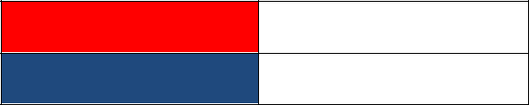

Key milestone

**Gant chart**

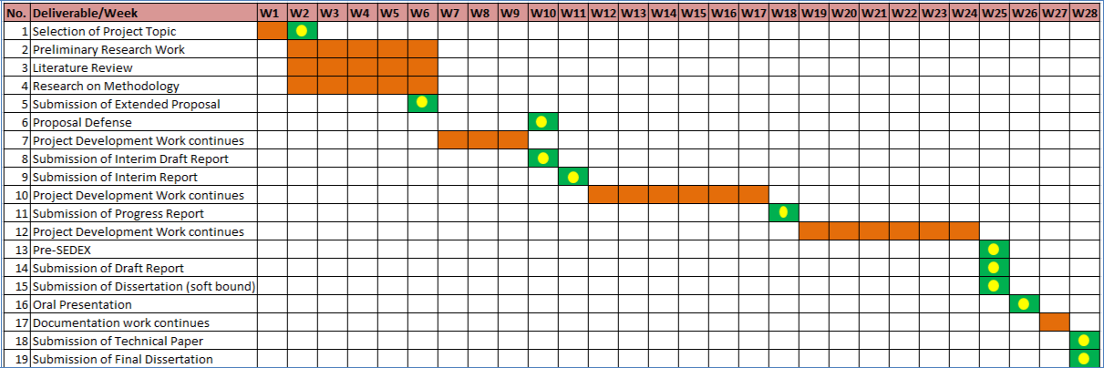

**CHAPTER 4:** **RESULT AND DISCUSSION**

**4.1. QUESTIONNAIRE SURVEY ANALYSIS**

The major instrument used for the study was a structured questionnaire. Pre-designed questionnaire was used in data collection. Copies of the questionnaire were given to student. The study involved a total of five (5) different engineering departments. The questionnaire is in the following table.

Questionnaire form (Refer to Appendix

Table 3. Survey

|  |  |  |
| --- | --- | --- |
| **Question** | **Pie Chart** | **Analysis** |
|  |  |  |
| 1. Do you use |  | 100% student |
| computer to |  | does not use |
| perform your |  | computers for |
| Examination? For |  | their tasks. |
| Example taking |  |  |
| Online |  |  |
| Examination |  |  |
| system for your |  |  |
| subject. |  |  |
|  |  |  |

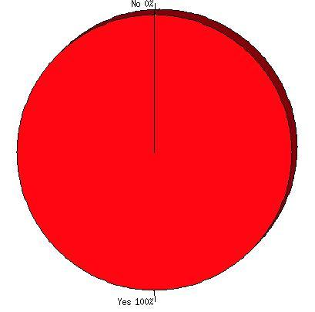

|  |  |  |
| --- | --- | --- |
| 2. Do you want to use |  | 80% of the |
| computer |  | respondents |
| application to |  | are willing to |
| perform for |  | use computer |
| Examination? |  | system to |
|  |  | perform their |
|  |  | Examination |
|  |  | while 20% |
|  |  | don’t want |
|  |  | use computer |
|  |  |  |
| 3. Will you use if we |  | 60% are ready |
| design for you an |  | to use the |
| online Examination |  | online |
| system? |  | Examination |
|  |  | system if we |
|  |  | developed it. |
|  |  | 20% are not |
|  |  | sure to use |
|  |  | 20% will not. |
|  |  |  |
| 4. Do you prefer |  | 60% prefer |
| online or offline |  | online system |
| application? |  | and 40% for |
|  |  | offline |
|  |  | system. |
|  |  |  |

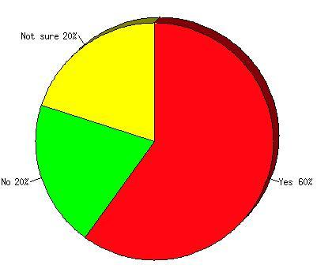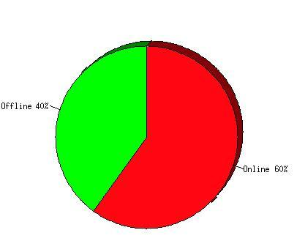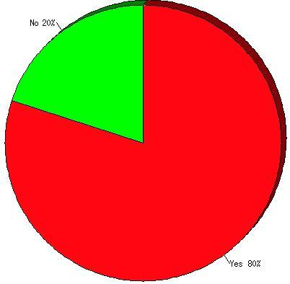

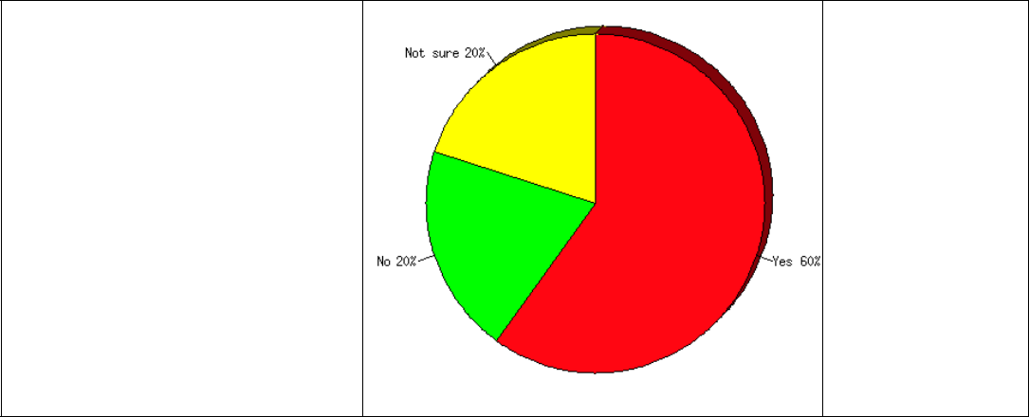 5. Do you think the Online Examination system will help you to do your Examination faster and see your result?

60% say yes.

20% are

not sure and

20% say no

**4.6. Database design**

The database is used for the purpose of handling information as an integrated whole. It is defined as a collection of interrelated data stored with less or no redundancy to serve many users quickly and effectively. We should design a database to see how data should be organized around user requirements. The objective of the database is to make information access, easy quick, inexpensive and flexible for other users. During database design the following objectives are concerned:

Controlled Redundancy

Data independence

Accurate and integrating

More information at low cost

Recovery from failure

Privacy and security

Performance

The tables used in the database are as follow:

Table Name: Users

|  |  |  |
| --- | --- | --- |
| Field Name | Data Type | Description |
|  |  |  |
| ID/ Staff | varchar2 | Primary Key |
|  |  |  |
| Password | varchar2 |  |
|  |  |  |
| Conformation Password | varchar2 |  |
|  |  |  |
| Mobile Number | varchar2 |  |
|  |  |  |
| Category | varchar2 |  |
|  |  |  |
|  |  |  |

Table Name**:** Questions Answers

|  |  |  |  |  |  |  |  |  |
| --- | --- | --- | --- | --- | --- | --- | --- | --- |
|  | Field Name | | | | Data Type | | Description | |
|  |  | | |  |  |  |  |  |
|  | Subject | | | | varchar2 | |  |  |
|  |  | | |  |  |  |  |  |
|  | Question Num | | | | Number | |  |  |
|  |  | | |  |  |  |  |  |
|  | questions | | | | varchar2 | |  |  |
|  |  | | |  |  |  |  |  |
|  | Choice1 | | | | varchar2 | |  |  |
|  |  | | |  |  |  |  |  |
|  | Choice2 | | | | varchar2 | |  |  |
|  |  | | |  |  |  |  |  |
|  | Choice3 | | | | varchar2 | |  |  |
|  |  | | |  |  |  |  |  |
|  | Choice4 | | | | varchar2 | |  |  |
|  |  | | |  |  |  |  |  |
|  | Correct Answer | | | | varchar2 | |  |  |
|  |  | | |  |  |  |  |  |
| Table Name: Result | | | | |  |  |  |  |
|  | |  |  | |  |  |  |  |
|  | | Field Name |  | | Data Type |  | Description |  |
|  | |  |  | |  |  |  |  |
|  | | ID |  | | Varchar2 |  |  |  |
|  | |  |  | |  |  |  |  |
|  | | Percentage |  | | Varchar2 |  |  |  |
|  | |  |  | |  |  |  |  |
|  | | Grade |  | | Varchar2 |  |  |  |
|  | |  |  | |  |  |  |  |

**4.7. INTERFACE REQUIREMENTS**

The user interface should be designed to make the user’s work easier and more effective and the principles for good interface design include concern for content and context for navigation through activities, aesthetic consideration, assistance for novices and experts, consistency, and minimizing user effort.

4.7.1 **Principles for User Interface Design**

The graphical user interface (GUI) is the most common type of interfaces most students are likely to use personally and for developing systems. The principles of interface are shown as follow:

**Layout** – The interface should be a series of areas on the screen that are used consistently for different purposes

**Content awareness** – Users should always aware where they are in the system and

what information is being displayed

**Aesthetics** – make interface look pleasing

**User experience** – Ease of use and ease of learning based on users’ level of

experiences

**Consistency** – enables users to predict what will happen before they perform the

function.

**Minimal user effort:**

The interface should be simple to use.

The screen: Information can be presented in multiple areas

Like areas should be grouped together

Areas and information should minimize user movement from one to another

Ideally, areas will remain consistent in Size, Shape, and Placement for entering data, and Reports presenting retrieved data.

**Content Awareness**

All interfaces should have titles.

⮚ Menus should show: where you are and where you came from to get

It should be clear what information is within each area.

Fields and field labels should be selected carefully.

Use dates and version numbers to aid system users.

**Aesthetics**

Interfaces need to be functional and inviting to use.

Avoid squeezing in too much, particularly for novice users.

Design text carefully.

Be aware of font and size.

Avoid using all capital letters.

Colors and patterns should be used carefully

Test quality of colors by trying the interface on a black/white monitor.

Use colors to separate or categorize items e.g. showing difference between headings and regular text.

The goal is pleasant readability, not art; color and patterns should be used to strengthen the message.

Colors with high contrast should be used (e.g. Black & white).

**Consistency**

⮚ Most important factor - enables users to predict what will happen.

When interfaces are consistent, users can interact with one part of the system, and then know how to interact with the rest.

Reduces learning curve.

Considers items within an application and across applications.

Pertains to many different levels

**Navigation controls**: Conveys how actions in the system should be performed – e.g.

using same icon or command.

**Form design:** Make it similar but give them some distinctive elements which enable users to detect differences.

**Interface Standards Design**

The basic elements that is common across individual screens, forms within the application

The standard serves as the touchstone that ensures the interfaces are consistent across the system

Interface Standard Elements

Defines how the interface will work. It is a concept from the real world that is used to model the computer system.

Helps user to understand and predict what features the interface might provide

**Interface templates:**

Define general appearance of all screens in the system and the paper- based forms and reports.

Specify the basic layout of the screen, status area, and form/report area(s) will be placed and the color scheme that will be applied.

**Interface objects**

Specify the names that the interface will use for the major interface object.

A more understandable name rather a more precise or more accurate one

Interface actions: Specifies the navigation and command language style

**4.8. TEST PLAN**

**4.8.1 Features to be tested**

**4.8.1.1. Interface**

We test how the system interacts with the environment and users. The system needs to be friendly user interface, such as beautiful, colourful, attractiveness. The interface will make the users to be easy to understand and perform our functions. It will minimize users less effort.

**4.8.1.2. User registration**

From testing part, this features need to be tested whether user registration feature meet some requirements especially security requirements. Firstly, in order for users to use the system, they need to be registered. We provide features for member registration. This feature must have the capability to provide a form in order to get the details about the user’s information like user’s name, username, password and category. Besides, those users who did not complete filling the registration form should not be allowed get access to the other section of the system.

4.8.1.3. **Send mail**

This feature allows lecturers to send mail to students.

4.8.1.4. **Add questions**

Enable lectures to add questions and answers into the system.

**4.9 TEST APPROACHES**

Testing will be developed by series of tests in the test plan. The test plan should address all products that are created during the development of the system. The test plan will be divided to the following stages; each stage will have differently testing approaches itself:

**4.9.1. Unit Testing**

Unit tests will focus on a single unit – the class. And the testers will check whether or not the class meets the requirements stated in the specifications or not. Unit test got 2 different approaches:

**4.9.2. Black – Box Testing**

The black – box testing will be used for normal unit testing. Each class represents an encapsulated object, treated class as “black – box”. Back – box testing is driven by the CRC cards, behavioral state machines, class diagrams, contracts associated with a class, not by the programmers’ interpretation.

**4.9.3. White – Box Testing**

The white – box testing is based on the method specifications associated with each class. This testing approach looks inside the class to test the code itself and its other major elements. The tester will use the white – box when the complexity is too high.

In our system, for testing unit, we decided to choose the Black – Box Testing. The reason for this decision is because of our system is not really complexity. It is simple with some functions which easy to understand. And our documentation did some kinds of diagrams already, such as CRC cards, class diagrams.

**4.9.4. Integration Testing**

Integration tests assess whether a set of classes that must work together do so without error. They ensure that the interfaces and links between different parts of the system

work properly. Integration tests will focus the flow of control among the classes and on the data exchanged among them.

**4.9.5. User Interface Testing**

The testing is done for normal integration testing, done by moving through each and every menu item in the interface either in a top – down or bottom – up manner. The testers will test each interface function, based on the interface design sources.

**4.9.6. Use – Case Testing**

The tester tests each use case, with the test plan source is use case diagram, when the user interface is important. Testing is done by moving through each use case to ensure they work correctly.

**4.9.7. Interaction Testing**

When the system performs data processing, the tester will use interaction testing. This testing will be performed base on some diagrams, such as class diagrams, sequence diagrams as well as communication diagrams. Interaction testing tests each process in a step – by – step fashion. Each class is added in turn and results of the class compared to the correct result from the test data. When a class passes, the next class is added and the test rerun. This is done for each package. Once each package has passed all tests, and then the process repeats integrating the packages.

**4.9.8. System Interface Testing:**

Because of data will be transferred between systems are often automated and not monitored directly by the users. So, it is critical to design tests to ensure they are being done correctly. The system interface testing will be used when the system exchange data with other systems, based on the use case diagram.

**4.9.9. System Testing**

System testing is similar to integration testing but is much broader in scope. It includes some kinds of testing.

**4.9.10. Requirements Testing**

Requirements testing will answer the question for normal system testing: How well the system meets business requirements? This testing will use system design, unit

tests and integration tests to answer, and ensure that changes made as a result of it did not create new errors. And besides, the testers often pretend to be uniformed users and perform improper actions to ensure the system is immune/avoid to invalid actions.

**4.9.11. Usability Testing**

The testers will use usability testing when user interface is important. It is based on the interface design and use case diagram to answer the question: How convenient the system is to use? It is done by the analyst with experience in how users think and in good interface design.

**4.9.12. Security Testing**

When the system is important, the testers will based on the infrastructure design to test the disaster recovery and unauthorized access. The security testing is quite complex, usually be done by an infrastructure analyst assigned to the project, or can hire professional firm, to answer the question: How secure the system is?

**4.9.13. Performance Testing**

The performance testing will answer the question: How well the system performs under a heavy load? This testing will used base on the system proposal and infrastructure. The testers will perform this testing by high volumes of transactions are generated and given to the system.

**4.9.14. Documentation Testing:**

And the last one in system testing is documentation testing. The test plan source of it will be help system, procedures as well as tutorial to test the accuracy of the documentation. The testers will check every item on every page in all documentation to ensure that the documentation items and examples work properly.

**4.10. TEST CASES**

**Test Case ID: 1**

Function to be tested: Register

Test Description: To register a user

Test Date: 5 April 2023

Tester: Khadkale Tanveer Maheboob

Test Objective: To ensure new user can register as member

Test Execution:

1. Launch the application
2. Enter ID
3. Enter Password
4. Mobile Number
5. Category
6. Click Save button

Expected Result: User will be successfully registered

Actual Result: Pass

**Test Case ID: 2**

Function to be tested: Login

Test Description: Enable registered users to log in to the system

Test Date: 5 April 2023

Tester: khadkale Tanveer Maheboob

Test Objective: To ensure registered users enter valid username and password while logging in.

Test Execution:

1. Enter ID
2. Enter password
3. Click Login button

Test Data :

1. ID – 12272
2. Password – 1234

Expected Result: User will be successfully log in

Actual Result: Pass

**Test Case ID: 4**

Function to be tested: send email

Test Description: To send an email

Test Date: 5 April 2023

Tester: Khadkale Tanveer Maheboob

Test Objective: To ensure an email can be sent

Test Execution:

1. Enter recipient address
2. Enter Subject
3. Browse file if there is
4. Write message
5. Click Send button

Expected Result: The message will be successfully sent

Actual Result: Pass

**Test Case ID: 5**

Function to be tested: Add questions

Test Description: To add questions and answers into the system

Test Date: 5 April 2023

Tester: Khadkale Tanveer Maheboob

Test Objective: To ensure questions and answers can be added

Test Execution:

1. Enter subject code

2. Question number

1. question
2. choice1
3. choice2
4. choice3
5. choice 4
6. correct answer
7. Click Save button

Expected Result: The above will be successfully saved

Actual Result: Pass

**4.11.** **Test tools needed.**

For this system, there is no special test tool. It is because the system desktop application and we are testing it by using the scenario-based cases using personal computers such as laptop or desktop. For example, the tester of this system will put particular data into that system and see whether the expected output will come out or not.

**4.12. Interface Design**

This section contains some screenshots of the components of the system.

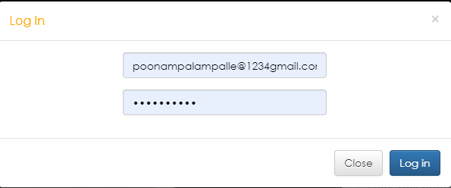

Figure 6. Login Screen that allow the user login to the system.

**Code**

import java.awt.*;

import java.awt.event.*;

import javax.swing.*;

import java.sql.*;

class LoginPage extends JFrame implements ActionListener

{

JLabel lnl,pwl,ch,ch1,nusr;

JTextField lnt;

JPasswordField pwt;

JButton ok,can,btnr;

Container c;

String ln,psw;

Connection conn;

PreparedStatement pstmt;

static final String JDBC_DRIVER = "importcom.mysql.jdbc.Driver";

static final String DB_URL = "jdbc:mysql://localhost:3306/internship";

static final String USER = "root";

static final String PASS = "";

public LoginPage()

{

super("Login Page...");

c=getContentPane();

resize(400, 280);

Dimension d=size();

setLocation(d.width,d.height);

setTitle("Login");

c.setLayout(null);

lnl=new JLabel("ID/STAFF:");

lnt=new JTextField();

lnl.setBounds(20,20,80,30);

lnt.setBounds(150,20,210,30);

pwl=new JLabel("PASSWORD:");

pwt=new JPasswordField();

pwl.setBounds(20,70,80,30);

pwt.setBounds(150,70,210,30);

ok=new JButton("OK",new ImageIcon(ClassLoader.getSystemResource("Images/login.png")));

ok.setBounds(150,120,100,30);

can=new JButton("CANCEL",new ImageIcon(ClassLoader.getSystemResource("Images/cancel.png")));

can.setBounds(260,120,100,30);

nusr=new JLabel(" NEW USER: ");

nusr.setBounds(20,165,150,s30);

btnr=new JButton("Register");

btnr.setBounds(150,169,210,30);

pwl.setFont(new Font("monospaced", Font.BOLD, 14));

lnl.setFont(new Font("monospaced", Font.BOLD, 14));

ok.setFont(new Font("monospaced", Font.BOLD, 12));

can.setFont(new Font("monospaced", Font.BOLD, 12));

btnr.setFont(new Font("monospaced", Font.BOLD, 14));

nusr.setFont(new Font("monospaced", Font.BOLD, 14));

lnt.setFont(new Font("monospaced", Font.BOLD, 14));

* ok = new JButton("OK", new ImageIcon(ClassLoader.getSystemResource("Images/login.png")));
* can = new JButton("CANCEL",new ImageIcon(ClassLoader.getSystemResource("Images/cancel.png")));

c.add(lnl);

c.add(lnt);

c.add(pwl);

c.add(pwt);

c.ad

='" + pwt.getText() + "'");c.add(can);

c.add(nusr);

c.add(btnr);

ok.addActionListener(this);

can.addActionListener(this);

btnr.addActionListener(this);

setVisible(true);

}

public void actionPerformed(ActionEvent e) {

if (e.getSource() == ok) {

try {

//Class.forName("sun.jdbc.odbc.JdbcOdbcDriver");

// Connection con = DriverManager.getConnection("jdbc:odbc:Internship");

Class.forName("com.mysql.jdbc.Driver");

conn=DriverManager.getConnection(DB_URL, USER, PASS);

try {

* pstmt =conn.prepareStatement("INSERT INTO Users (ID, Password, firstName, lastName, Email, phoneNum, Category, DateOfBirth) VALUES ('" +

Statement st = conn.createStatement();

ResultSet rs = st.executeQuery("SELECT * FROM users WHERE ID='" + lnt.getText() +

"' and Password

if (rs.next()) {

if (rs.getString(4).equals("Lecturer")) {

LecturerPage frm = new LecturerPage()

frm.setVisible(true);

} else {

String one=rs.getString("ID");

Rules ru=new Rules(one);

ru.setUp();

setVisible(false);

dispose();

}

this.dispose();

}else{

JOptionPane.showMessageDialog(null,"Invalid username or password","Invalid",JOptionPane.ERROR_MESSAGE);

}

conn.close();

} catch (Exception ex) {

JOptionPane.showMessageDialog(null, "Invalid username or password", "Invalid", JOptionPane.ERROR_MESSAGE);

lnt.setText("");

pwt.setText("");

}

} catch (Exception x) {

JOptionPane.showMessageDialog(null, "Unable to connect to the database", "Connection error", JOptionPane.ERROR_MESSAGE);

}

}

if (e.getSource() == can) {

System.exit(0);

}

if (e.getSource() == btnr) {

new Register().setVisible(true);

//System.exit(0);

}

}

public static void main(String args[])

{

new LoginPage().setVisible (true);

}

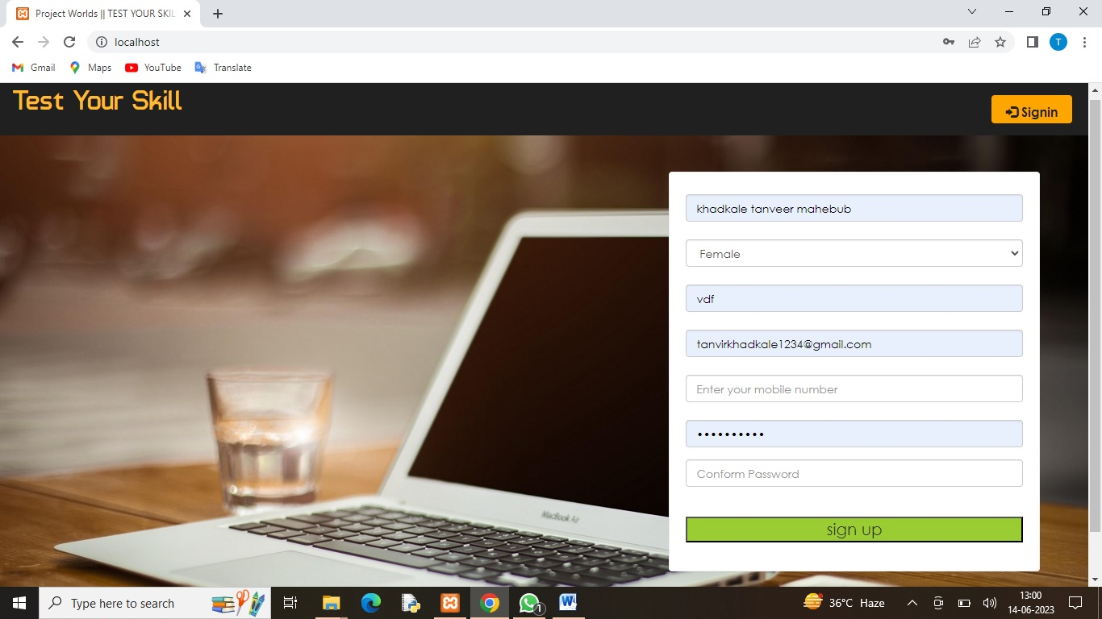

Figure 7: Registration page

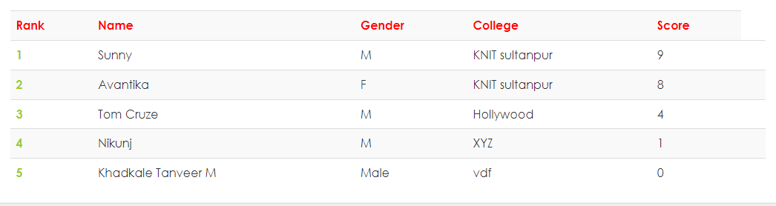

Figure 8: Students with grade

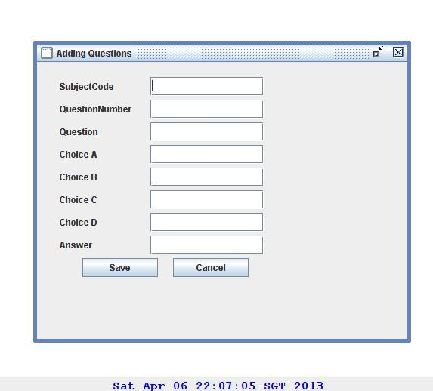

Figure 9: Adding questions to the database

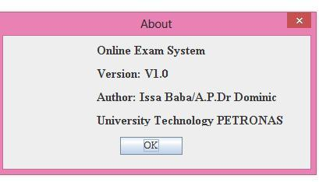

Figure 10 : about the version of the system the current version is V1.0 with the author names .

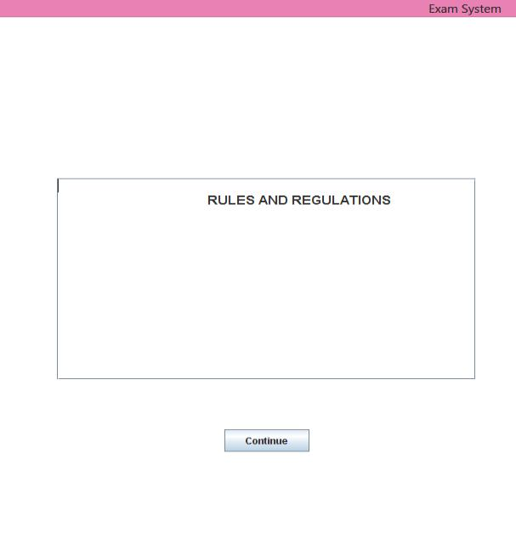

Figure 11: student page.

Figure 12: Selection of exam this page allow the student to select the exam

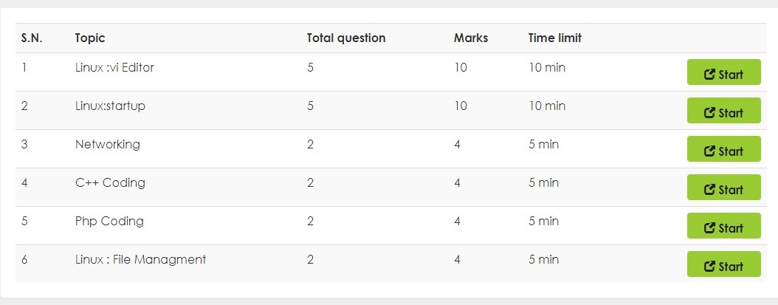

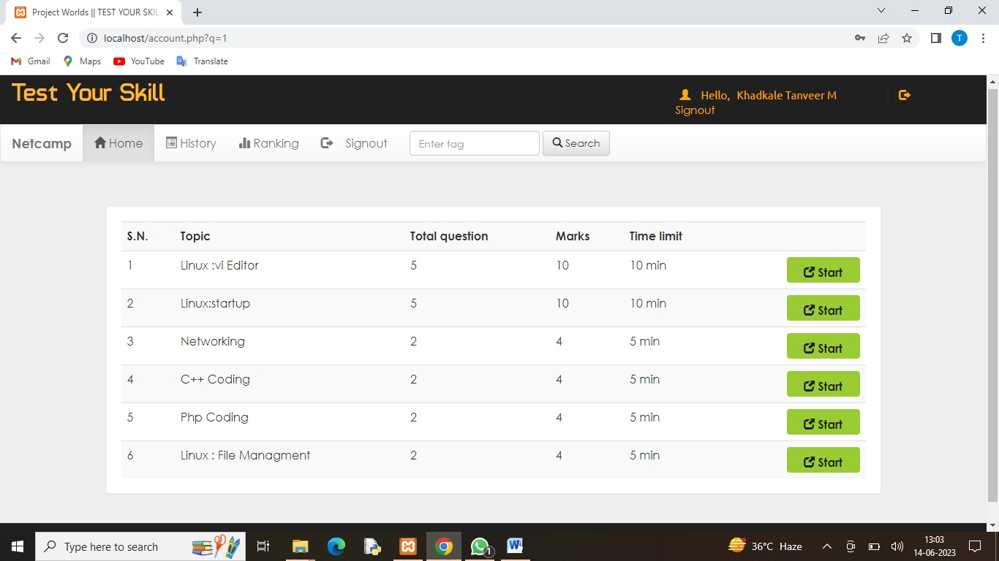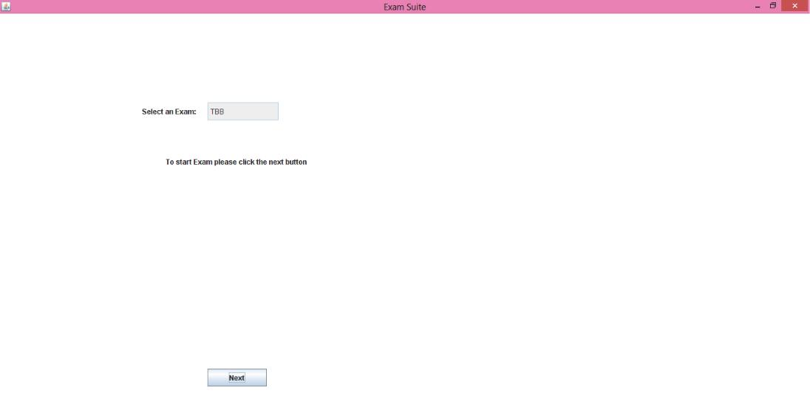

Figure 13: Exam question this page allows the student to start they are exam.

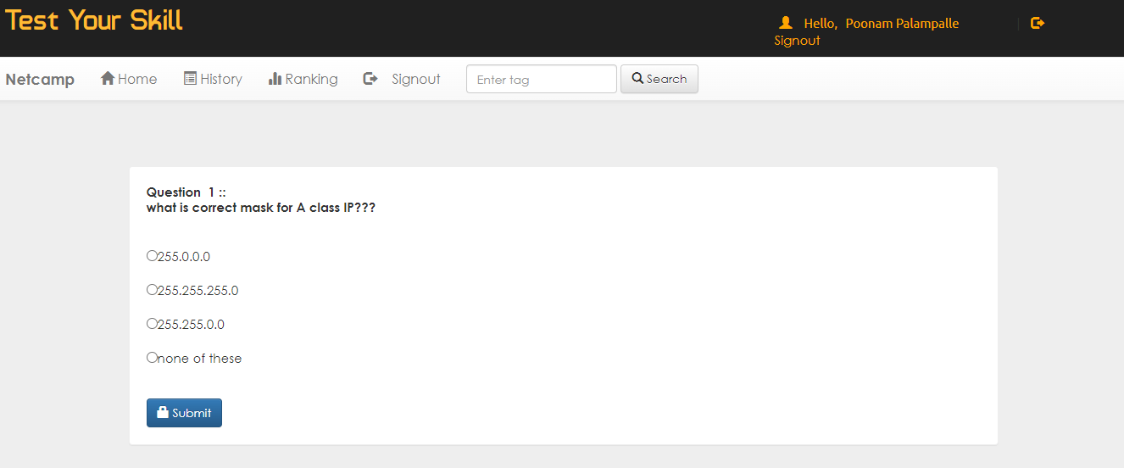

Figure 14: Exam question.

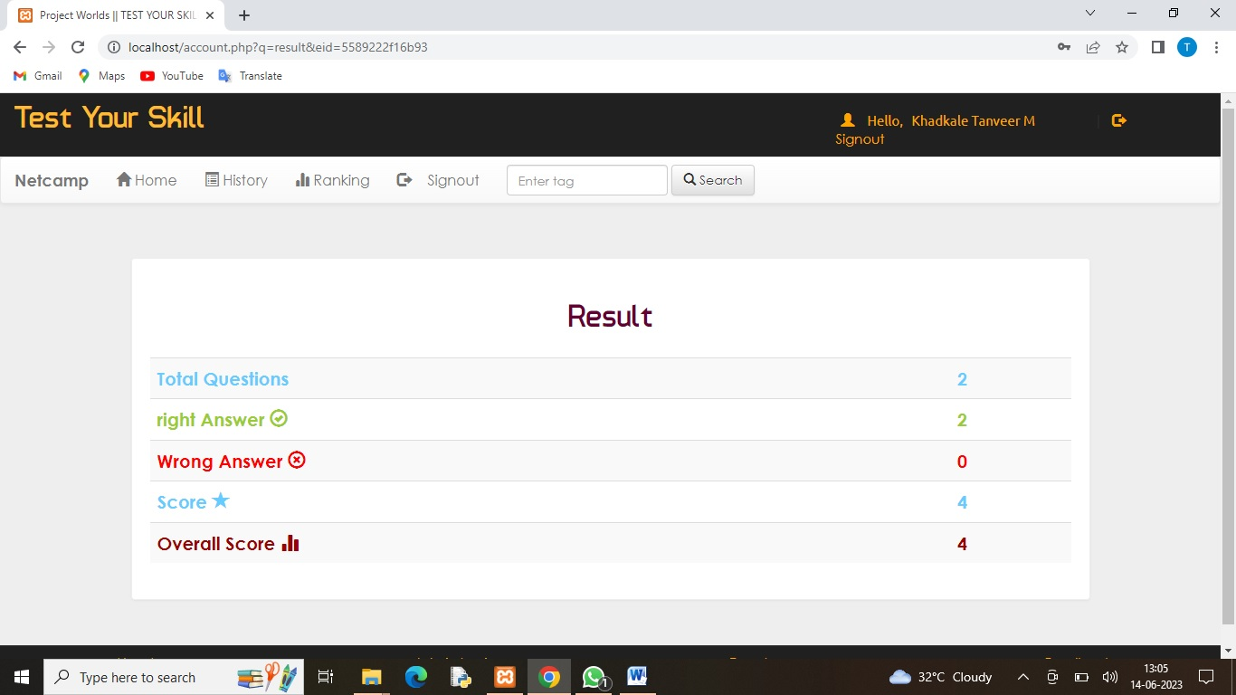

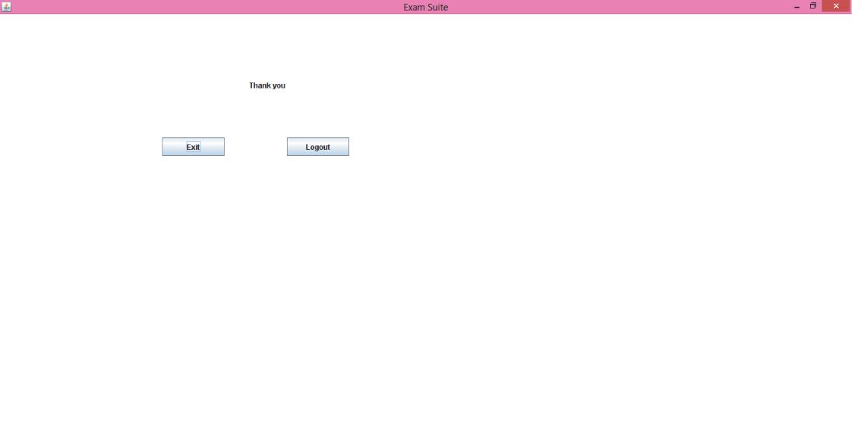Figure 15: End of exam page.

**CHAPTER 5: CONCLUSION & RECOMMANDATION**

* 1. **CONCLUSION**

With the completion of this project I conclude that it has achieved its purpose. The whole project provides a base for students to take their exam using software and allow lecturers to add questions and answers into the system. The system is developed using Java programming language and data are saved in the database.

Online examination system for introduction to management course is the best compared to paper-based exam. The automated system helps students and lecturers to save time and makes the process faster. It saves space since answers papers will not be used. With a user friendly system that has security, integrity and the database is neither inconsistent nor redundant.

**5.2 Recommendations:**

The project has been accomplished and an application was developed to solve the aforementioned problems. For further development, there are some recommendations on this project:

The application should support an automated time setting to let the student know how many hours and minutes are left for them to complete the examination.

**REFERENCES**

1. Nijaz.(2000). Dynamic Web-based Application Development. New York:Prentice Hall
2. Enright, A.G., and Libert, T., "The Web: It's not just for E-mail Anymore", American Society for Engineering Education (ASEE) Annual Conference Proceedings, Charlotte, North Carolina, 1999.
3. Newton, Harry, "Newton’s Telecom Dictionary", 14th Edition, 1998
4. Ritchey, Tim, and Shobe, Matt, "JavaScript For Macintosh", 1996
5. Harold, Elliotte Rusty, "Java Network Programming", 1997
6. Biedny, David, and Monroy, Bert, "Adobe Photoshop Handbook", 2.5 Edition, 1993
7. Alba, J.W. and Barton Weitz, J.L. (1997), “Interactive home shopping:

consumer, retailer, andmanufacturer incentives to participate in electronic marketplaces”, Journal of Marketing , Vol.61, July, pp. 38-53.

1. Eighmey, J., “Profiling user responses to commercial Web sites”, Journal of

Advertising Research, Vol.37, No. 3:59-66, 1997

1. Bryan, J. (2006). Technology for physics instruction. Contemporary Issues in Technology and

Teacher Education, 6(2), 230-245.

1. Gina, C. O. and Bob O, Viewing the WEB as a marketplace: the case of small companies, *Decision Support Systems*, Vol. 21, No. 3, 1997, pp. 171-183.
2. Mund, Andre, Rotsawatsuk, Prawit, and Sawhney, Anil, "Enhancing Construction Engineering Education Using Internet based Tools", American Society for Engineering Education (ASEE) Annual Conference Proceedings, North Carolina, 1999.

**APPENDICES**

**QUESTIONNAIRE FORM**

1. The synchronous modems are more costly than the asynchronous modems because?

* they produce large volume of data
* they contain clock recovery circuits
* they transmit the data with stop and start bits.
* they operate with a larger bandwidth

2) Telnet is a ______ based computer protocol?

* Sound
* Text
* Image
* Animation

3) Computers that control processes accept data in a continuous __________?

* data traffic pattern
* data highway
* infinite loop
* feedback loop

4) Computers connected to a LAN can?

* run faster
* go on line
* share information and/or share peripheral equipment
* E-mail

5) Computer and communication technology, such as communication links to the Internet, that provide help and understanding to the end user is known as?

* presentation file
* information technology
* program
* worksheet file

6) Device that connects to a network without the use of cables is said to be?

* distributed
* centralised
* open source
* wireless

7) Codec refers to?

* Coder-decoder
* Co-declaration
* Command declaration
* Command decoding